Write the following basic Python program

\\1.Write the program to print <Your name>.

print("ENTER YOUR NAME")

n=input()

print(n)

\\OUTPUT:

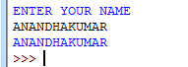

2. Write the program to read input from the user and print 'welcome <Your name>'

print("ENTER YOUR NAME")

n=input()

print("welcome",n)

\\output:



3. Write the program to read three inputs from the user as numbers and add all three numbers (use explicit data type conversion).

print("ENTER THE NUMBER")

a=int(input())

b=int(input())

c=int(input())

print(a+b+c)

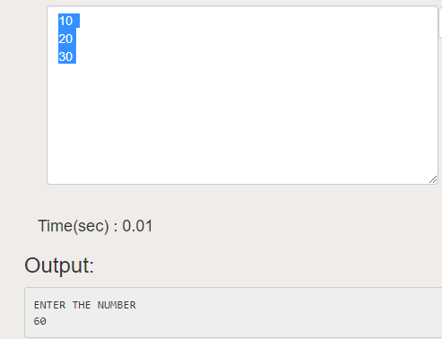

4. Write the program to read three inputs from the user as numbers (Data types -> int,float,complex number) and add all three numbers (use explicit data type conversion).

print("ENTER THE NUMBER")

a=int(input())

b=float(input())

c=complex(input())

print(a+b+c)

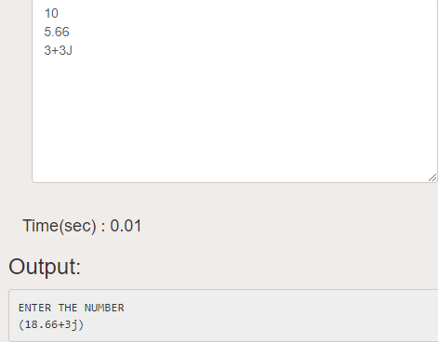

5. Write a program to perform all arithmetic operations.

print("ENTER THE NUMBER")

a=int(input())

b=int(input())

print(a+b)

print(a-b)

print(a*b)

print(a/b)

print(a%b)

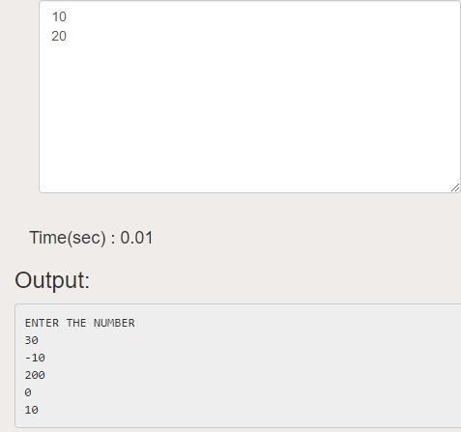

6. Write a program to perform all relational operations.

print("ENTER THE NUMBER")

a=int(input())

b=int(input())

print(a<b)

print(a>b)

print(a<=b)

print(a>=b)

print(a==b)

print(a!=b)

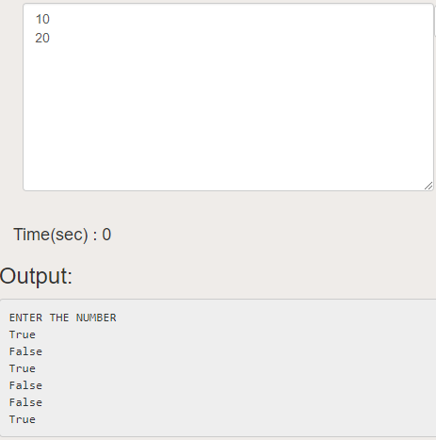

**7. Write program to perform all logical operations.**

print("ENTER THE NUMBER")

a=True

b=False

print(a and b)

print(a or b)

print(not a)

print(not b)

***output***

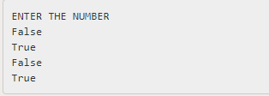

8. Write a program to perform all bit wise operations

print("ENTER THE NUMBER")

a=input()

b=input()

print(a&b)

print(a|b)

print(~a)

print(a^b)

print(a>>b)

print(a<<b)

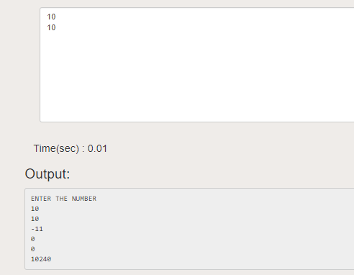

**9. Write a program to perform all conditional operations.**

**10. Write a program to perform all member ship operations.**

a='python'

print('p' in a)

print('a'not in a)

